9-18-2015. Adam Wroblewski and Roger Tokars HSI operators. Pilot Jim Demers and copilot.
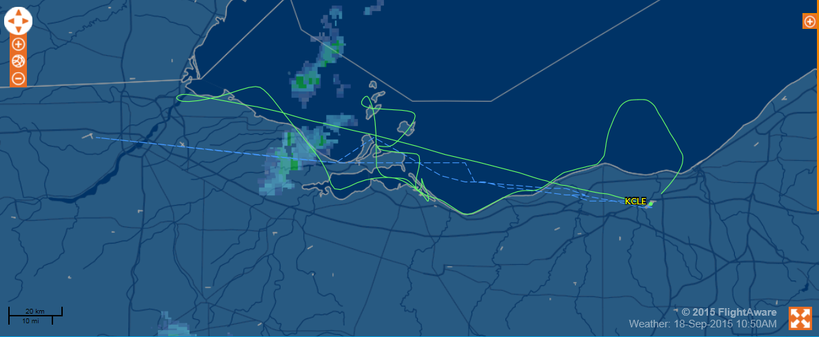

Takeoff 9:41am Land 12pm Duration 2:19
Partly cloudy
Headed straight out to MBSP to beat clouds
Rain MBSP 6500’
6500 over SAN
Gibraltar 3 vessel. Mirror present.
6500 over stone labs
Dropped down to 3500’ for remainder of flight.
3500 over stone labs. Mirrors present.
3500 over San 1 2 and Gibraltar 3 vessel. Boat seen on waterfall image. Mirrors present.
San8 3500’ water intake. Mirrors present.
Sky radiometer wasn’t collecting data during beginning half of flight. Started saving data within last hour of flight which was much brighter during this time. Need to mitigate this issue with a checklist procedure.
Collected data halfway to Canada Airspace (about 10 miles out from Cleveland Water Intake Crib) and all the way to Cleveland intake.

